Olmsted SWCD Seed and Plant Sale 2024
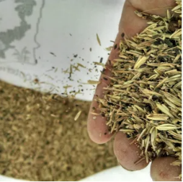
Seed Mixes:
We offer several seed mixes to choose from, all comprised of local-ecotype seed native to Minnesota. All seed mixes have native grass/sedge and wildflower components unless otherwise indicated. Cover crop and filler also included for best planting success. Seed mixes available include:

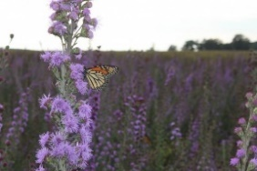
Pollinator Mix: Our most diverse mix for pollinators. Grasses, sedges, and over 25 wildflower species, for dry to mesic soil conditions. 2-3’ height.

100 sq. ft. - $25.00
1000 sq. ft. - $70.00
5000 sq. ft. - $230.00
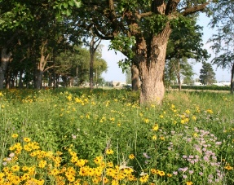
Savanna Mix: Great mix for part-sun oak savanna and woodland edge sites with 25-50% tree cover. Height 2-4’

1000 sq. ft. - $65.00
5000 sq. ft. - $200.00

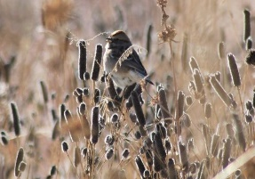
Songbird Mix: A mix of species to provide beneficial forage and habitat for MN native songbirds. Best for dry to mesic soils, height 2-5’

100 sq. ft. - $25.00
1000 sq. ft. - $56.00
5000 sq. ft. – 170.00
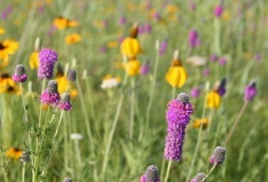
Upland Dry Shortgrass Prairie Mix: Grass and wildflowers ranging 2-3’ in height, for well drained or sandy soil.

1000 sq. ft. – $55.00
5000 sq. ft. - $155.00
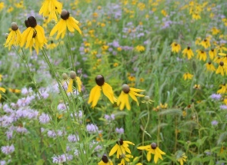
Mesic Tallgrass Prairie Mixes: Wildflower and grass mixture. 3-6’ in height, for medium to clay soil.

1000 sq. ft. - $55.00
5000 sq. ft. - $145.00

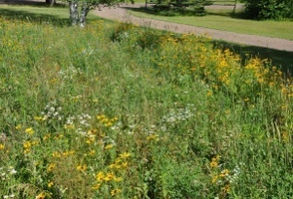
Septic Mound Mix: Designed to provide stable and attractive ground cover and erosion control in poor quality septic mound soils. A great way to add beneficial native habitat and eye appeal to unattractive septic mounds. Heigh 1-3’

1000 sq. ft. - $60.00
5000 sq. ft. - $170.00

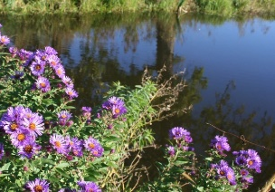
Shoreland Mix: Shorter grasses and sedges in this mix highlight a diverse list of wildflowers for shoreline areas. 2-3’ of undergrowth with taller blooming flowers. Best planted 1-2’ up from water’s edge.

1000 sq. ft. - $105.00
5000 sq. ft. - $360.00
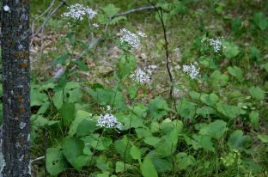
Woodland Mix: Shade tolerant mix perfect for woodland understories. 1-5’ in height.

100 sq. ft. - $25.00
1000 sq. ft. – $135.00
5000 sq. ft. - $485.00

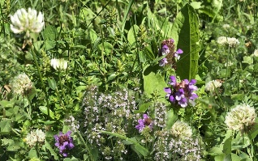
Bee Lawn: A short stature, pollinator-friendly, and low maintenance alternative to traditional turf. Non-native but a low input option for “use areas” of your lawn or at the cabin.

1000 sq. ft. - $85.00

Live Plant Kits:
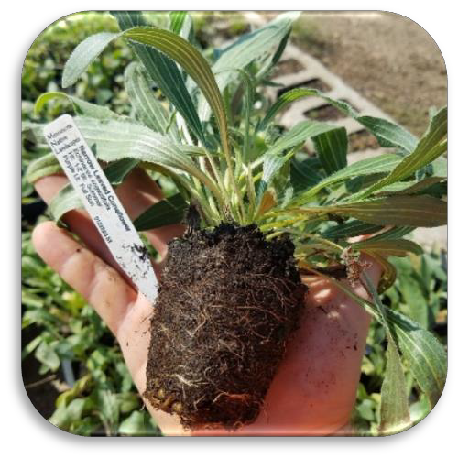
Plant kits consist of one tray containing 36 plugs of 6 different species and cost $70.00 ($1.94/plug).
Plant Kits will include 6 different flowers and grasses.

These will be a mix of species curated specially for each kit.

Specific plant kit species lists will be determined after final sale. This will ensure availability, readiness for transport, and customer satisfaction.

All plants will be suitable and representative of the natives for your geographic area.
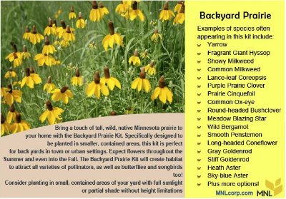
Backyard Prairie Kit: An attractive mix of native prairie species for your back yard. Grows will in dry to mesic soils and full sunlight. Heights ranging 36” and up.

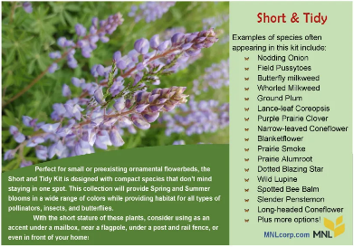
Short and Tidy Kit: A mix of short – statured, well behaved prairie species. Perfect for existing flowerbeds with mesic soil and full to partial shade. Up to 36” in height.

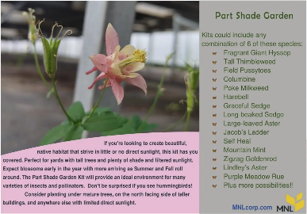
Shade Garden Kit: Designed for areas with limited direct sunlight

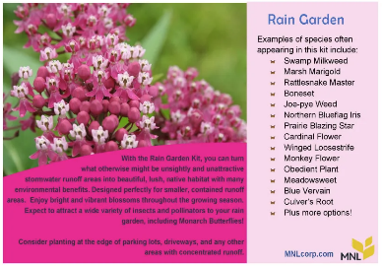
Rain Garden Kit: Mesic to moist soil species. Perfect for areas of concentrated runoff and occasional inundation.

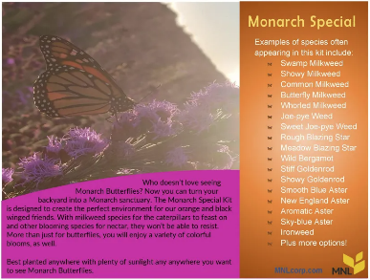
Monarch Special Kit: A mix of milkweed varieties to host Monarch caterpillars and fall-blooming nectar favorited for monarch butterflies.

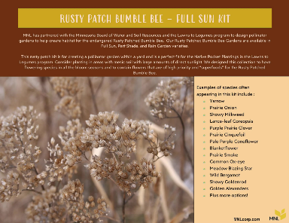
Rusty Patch Bumble Bee Kit: A collection of “superfood” species for our endangered Minnesota State Bee for areas with plenty of sunlight.

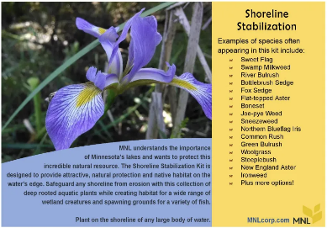
Shoreline Stabilization Kit: Deep-rooted, wet-soil species to help prevent erosion along large bodies of water.

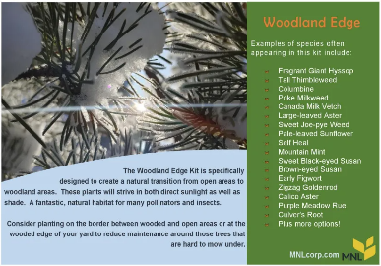
Woodland Edge Kit: Perfect for areas with a mix of sun and shade along tree lines and at woodland edges.

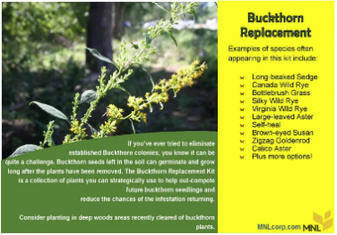
Buckthorn Replacement Kit: Aggressive species for wooded areas to help combat buckthorn.
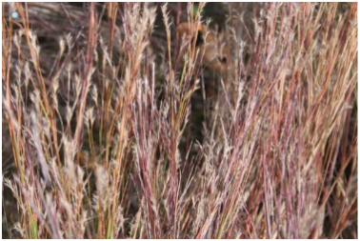
Prairie Grass Kit: A mix of native prairie grasses. Plant on its own or use along side kits to provide ground cover, a more natural prairie look, and support for wildflowers.

